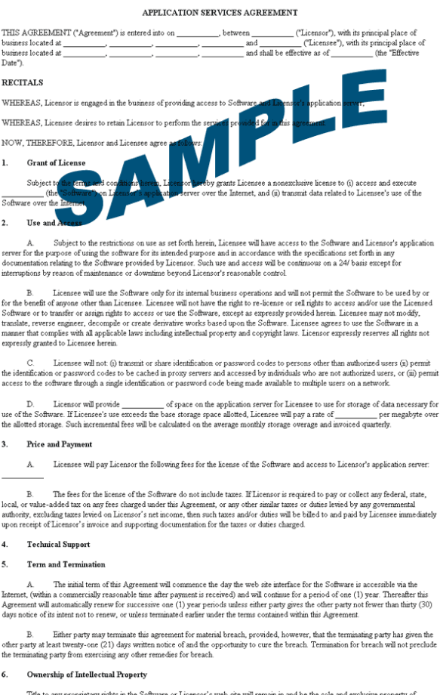
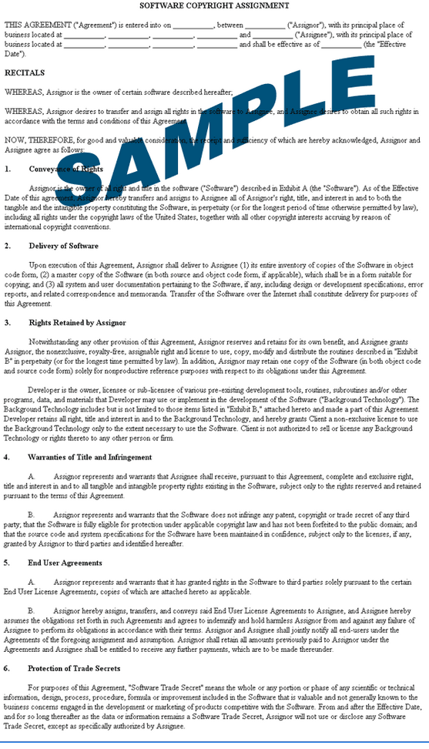
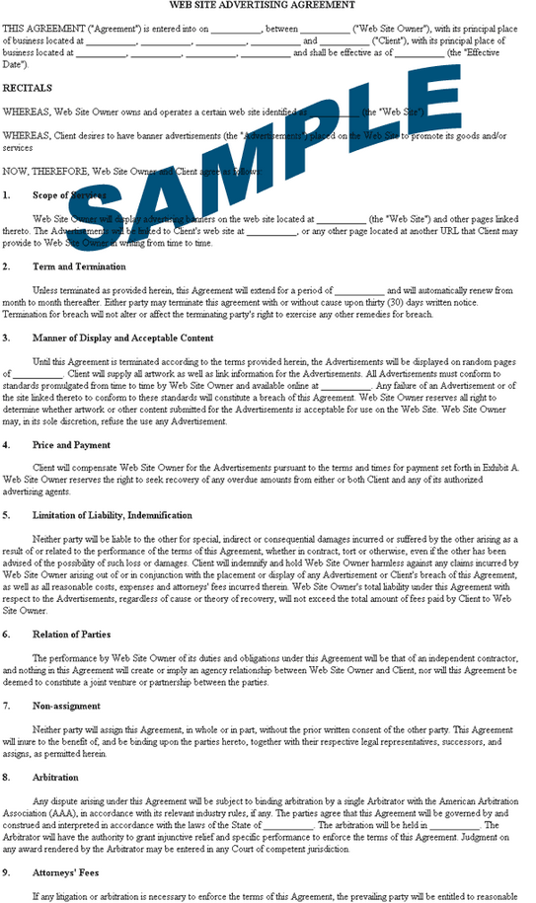
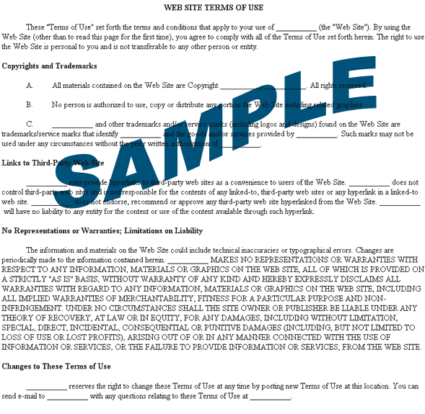
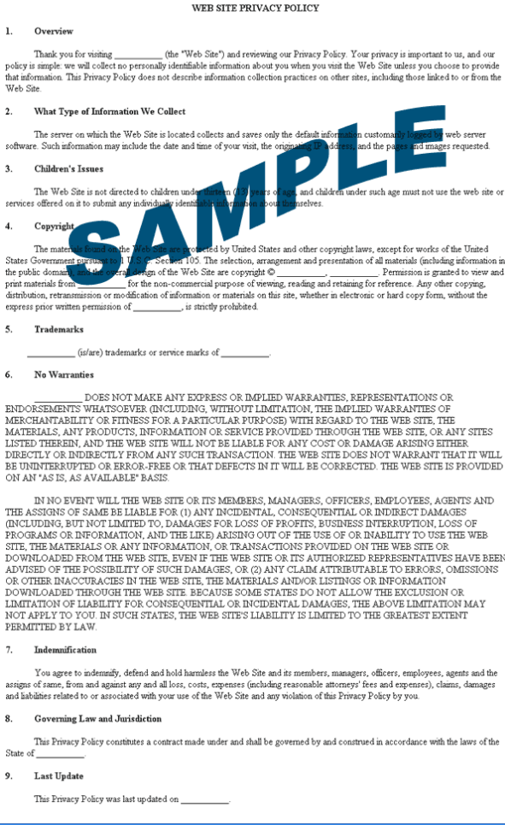
Confidentiality Agreement
It is understood and agreed to that the below identified discloser of confidential information may provide certain information that is and must be kept confidential. To ensure the protection of such information, and to preserve any confidentiality necessary under patent and/or trade secret laws, it is agreed that
1. The Confidential Information to be disclosed can be described as and includes:
Invention description(s), technical and business information relating to proprietary ideas and inventions, ideas, patentable ideas, trade secrets, drawings and/or illustrations, patent searches, existing and/or contemplated products and services, research and development, production, costs, profit and margin information, finances and financial projections, customers, clients, marketing, and current or future business plans and models, regardless of whether such information is designated as “Confidential Information” at the time of its disclosure.
2. The Recipient shall limit disclosure of Confidential Information within its own organization to its directors, officers, partners, members, employees and/or independent contractors (collectively referred to as “affiliates”) having a need to know. The Recipient and affiliates will not disclose the confidential information obtained from the discloser unless required to do so by law.
3. This Agreement imposes no obligation upon Recipient with respect to any Confidential Information (a) that was in Recipient’s possession before receipt from Discloser; (b) is or becomes a matter of public knowledge through no fault of Recipient; (c) is rightfully received by Recipient from a third party not owing a duty of confidentiality to the Discloser; (d) is disclosed without a duty of confidentiality to a third party by, or with the authorization of, Discloser; or (e) is independently derived by Recipient.
4. This Agreement states the entire agreement between the parties concerning the disclosure of Confidential Information. Any addition or modification to this Agreement must be made in writing and signed by the parties.
5. If any of the provisions of this Agreement are found to be unenforceable, the remainder shall be enforced as fully as possible and the unenforceable provision(s) shall be deemed modified to the limited extent required to permit enforcement of the Agreement as a whole.

